RIPHAH INTERNATIONAL UNIVERSITY



Computer Organization & AL Lab
Lab 10

Task 1:
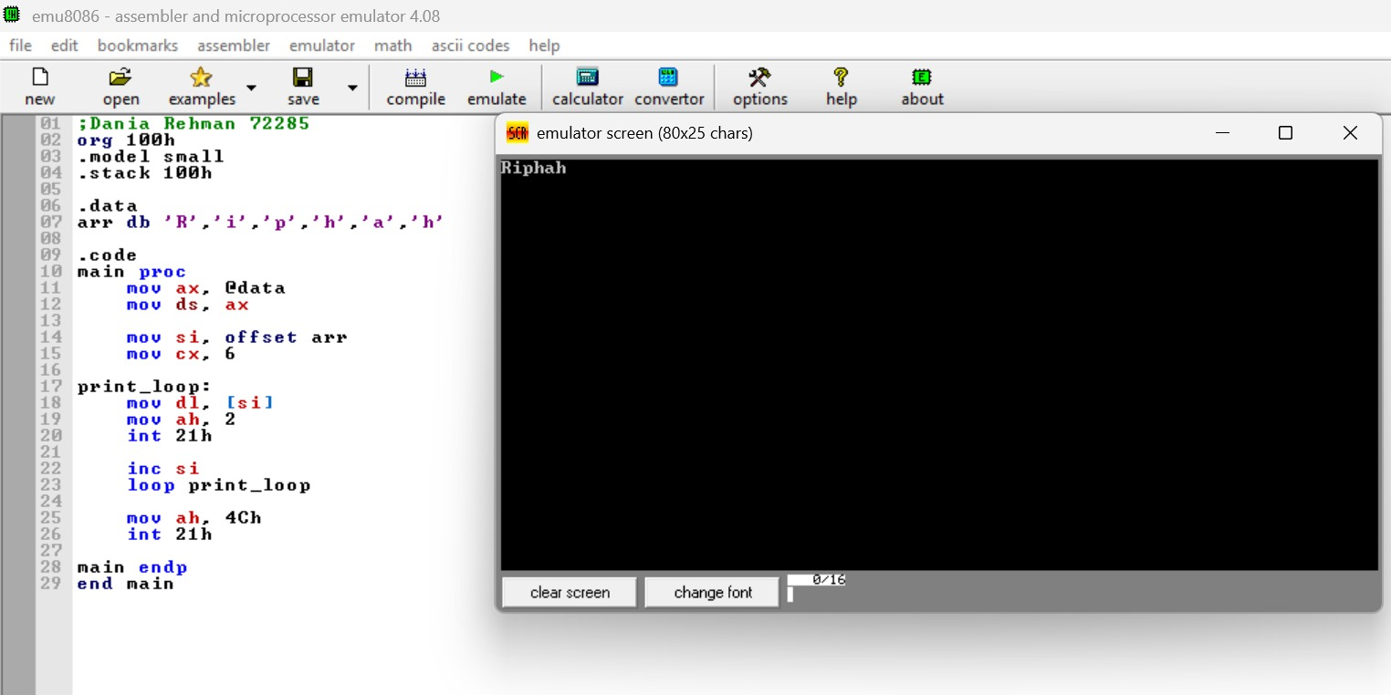

Task 2:
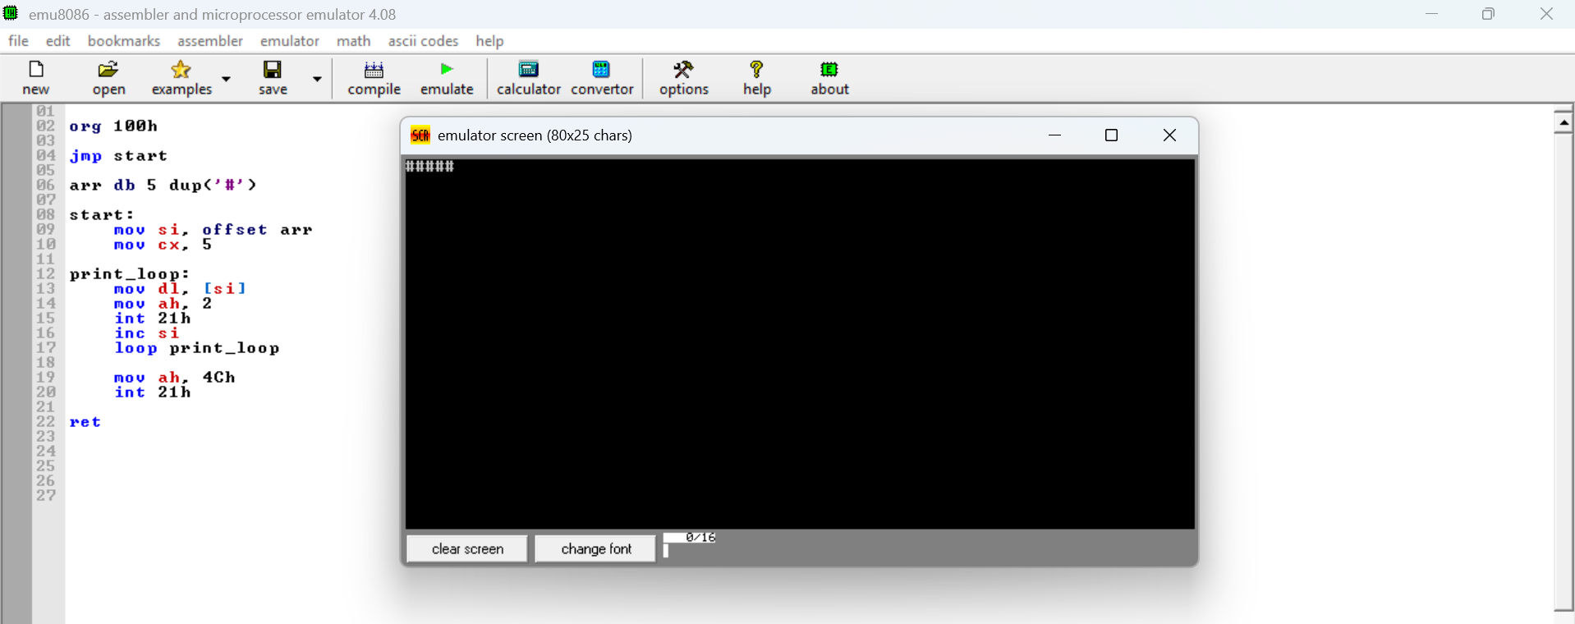

Task 3:


